Dear Parents,

Attached is the EOC review assignment for Tuesday, March 24.

This assignment reviews the following topics:

Plotting points

The coordinate plane:

The horizontal axis is labeled as the x-axis.

The vertical axis is labeled as the y-axis.

The origin is the center of the coordinate plane and the ordered pair is (0, 0)

A coordinate pair is labeled (x, y) so make sure your answer is always in parenthesis. The first coordinate is always the x-value. The x-axis goes left (-) and right (+). The y-axis goes down (-) and up (+).

To plot a point: First, move left (-) or right (+). Then, move down (-) or up (+).

There are four quadrants which are counter clockwise in direction

Quadrant I: both x and y are positive; x > 0, y > 0
Quadrant II: x is negative and y is positive; x < 0, y > 0
Quadrant III: both x and y are negative; x < 0, y < 0
Quadrant IV: x is positive and y is negative; x > 0, y < 0

To find the x-intercept, ignore the y term (because plugging in 0 for y and 0 times anything is 0). Divide by the number in front of x. The x-intercept will be x = #. To plot the x-intercept on a coordinate plane, find the number on the x-axis.

To find the y-intercept, ignore the x term (because plugging in 0 for x and 0 times anything is 0). Divide by the number in front of y. The y-intercept will be y = #. To plot the y-intercept on a coordinate plane, find the number on the y-axis.
Example 1: x + 7y = 7
- To find x-intercept, ignore 7y: x = 7
So, the x-intercept is x = 7 or as an ordered pair (7, 0) which goes on the x-axis
- To find y-intercept, ignore x: 7y = 7 Divide both sides of equal sign by 7
So, the y-intercept is y = 1 or as an ordered pair (0, 1) which goes on the y-axis

Example 2: 10x – y = 20
- To find x-intercept, ignore - y: 10x = 20 Divide both sides of equal sign by 10
So, the x-intercept is x = 2 or as an ordered pair (2, 0) which goes on the x-axis
- To find y-intercept, ignore 10x: - y = 20 Divide both sides of equal sign by – 1

So, the y-intercept is y = - 20 or as an ordered pair (0, - 20) which goes on the y-axis

Example 3: y = - 1

Since this is a horizontal line with a slope of zero, there is no x-intercept

The y-intercept is y = - 1 or as an ordered pair (0, - 1) which goes on the y-axis

Example 4: x = - 4

Since this is a vertical line with an undefined slope, there is no y-intercept

The x-intercept is x = - 4 or as an ordered pair (- 4, 0) which goes on the x-axis

Average Rate of Change (slope = m): To find the average rate of change, there must be two ordered pairs: The formula is as follows: m = 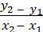 or 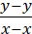

The first number (the x values) in each parenthesis will go on the bottom of the fraction and the second number (the y values) in each parenthesis will go on the top of the fraction.

If the x values are the exact same, then the slope will be undefined since you cannot divide by zero.

If the y values are the exact same, then the slope will be zero since zero divided by any number is zero.

If only given the x values, then look at the graph or table to determine the ordered pair. Last, just plug in the numbers to the above formula.
The values, if written in brackets, represent x values. Students can find the corresponding y values from the calculators. Then, plug in the numbers to the above formula. Hint: whatever is in the bracket or whatever numbers are given will always go on the bottom of the formula (just separate the numbers with a minus sign).
If given x values and an equation, then plug in the x values everywhere there is an x. Next, enter this into your calculator to find the corresponding y value. Do this for both x values given. Then you will have your two ordered pairs to plug into the formula.
When looking at a graph, know that the most vertical part of the graph will have the fastest rate of change. The most horizontal part of the graph will have the slowest rate of change.

The top row represents the x values and the bottom row represents the y values in a table:
Example 1:
Year | 2010 | 2011 | 2012 | 2013
Number of animals | 63 | 55 | 47 | 39

So, the slope (rate of change) is as follows: 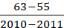 = - 8 (would expect negative rate of change since y values are decreasing

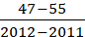 = - 8 (Still get the same answer no matter what set of points are chosen)

In a chart, the left column is x and the right column is y
Example 2:

x | y
-2 | 7
0 | 14
2 | 21
4 | 28

So, the slope (rate of change) is as follows: 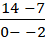 = (would expect positive rate of change since y values are increasing
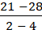 = (still get the same answer no matter what points are chosen)

Example 3: (- 13, 8) (3, 12)
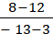 = ; this line would be headed uphill since the slope is positive

Example 4: (19, - 12) (5, 16)
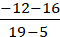 = - 2; this line would be headed downhill since the slope is negative

Example 5: ( - 7, 8 ) (- 7, - 5)

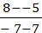 = undefined (calculator says cannot divide by 0, error); this line would be vertical since the slope is undefined (x coordinates same)

Example 6: ( 3, - 8) (- 4, - 8)
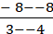 = 0; line would be horizontal since the slope is 0 (y coordinates same)

Finding Slope from a Graph, do the following:

Students can use the slope formula: rise/run:
- Rise refers to how many spaces are counted vertically (up or down), and run refers to how many spaces are counted horizontally (left to right).

- Students should read a graph from left to right. If the graph is headed uphill, then the slope will be positive. If the graph is headed downhill, then the slope will be negative. Horizontal lines will have a slope of zero. Vertical lines will have a slope of undefined.

Example 1:

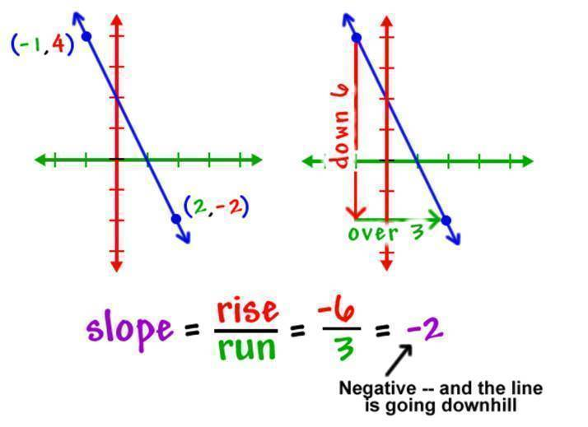

Example 2:
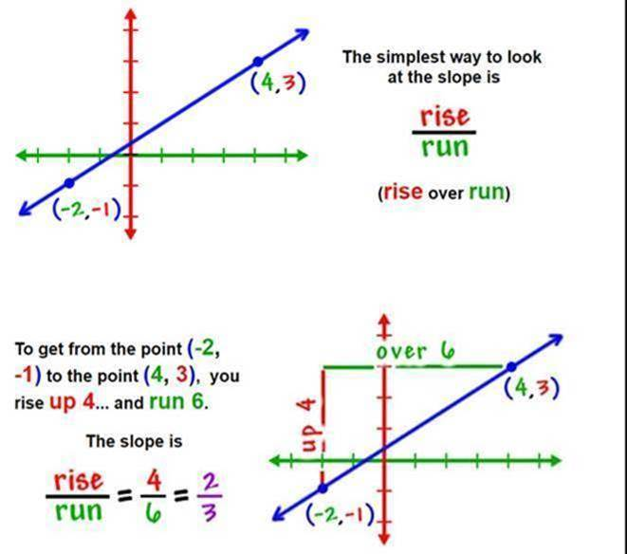

Graphing equations:
If the equation states x = # (no y in the equation), then students should know this is a vertical line that has a slope of undefined and no y-intercept (VUX: Vertical, undefined, x = #)
If the equation states y = # (no x in the equation), then students should know this is a horizontal line that has a slope of zero and the y-intercept is whatever the number is in the equation. (HOY: horizontal, slope of zero, y = #)
Slope intercept form is y = mx + b. The letter m stands for the slope which is rise/run. Rise stands for how far to count up or down. Run stands for how far to count left or right. The letter b stands for the y-intercept which is where the graph crosses the y-axis.
Standard form is AX + BY = C. If the equation is in standard form, then students should solve for y first. Students should do this by moving x first either by adding or subtracting the x term to both sides. Then students should divide by the number in front of y to all three terms. Then follow the steps listed below.

The steps given below are how to approach all problems with both an x and y:
First, make sure y is on a side by itself. If y is not on a side by itself, then you must get y on a side by itself. To get y on a side by itself then follow these steps: If x and y are on the same side of the equal sign, then add or subtract x to both sides of the equal sign. Then divide by the number next to y.

Example 1: 8x – 3y = 0; So, subtract 8x from both sides which gives: - 3y = - 8x + 0
Divide all terms by – 3 which gives the following answer: y = x + 0
So, the slope is which means up 8 and right 3 or down 8 and left 3
The y-intercept is 0 which means the origin

Example 2: 6y + 2x = 18; So, subtract 2x from both sides which gives: 6y = - 2x + 18
Divide all terms by 6 which gives the following answer: y = x + 3
So, the slope is which means down 1 and right 3 or up 1 and left 3
The y-intercept is 3 which means (0, 3)

Example 3: (x and y are not on the same side of the equal sign)
4x = 7y – 14; So, add 14 to both sides to get y on a side by itself which gives:
4x + 14 = 7y: Divide all terms by 7 which gives the following answer: x + 2 = y
So, the slope is which means up 4 and right 7 or down 4 and left 7
The y-intercept is 2 which means (0, 2)

Example 4: (there is no y so get x on a side by itself)
-X – 7 = 1 So, add 7 to both sides which gives – x = 8

Divide both sides by – 1 which gives x = - 8

So, the slope is undefined and there is no y-intercept since it is a vertical line.

1) State the y-intercept and then plot the y-intercept. This is the number only in the equation. This number goes on the y-axis which is the vertical axis. Pay attention to whether the number is positive or negative.
2) State the slope. This is the number in front of x. If the slope is not a fraction, then place the number over 1 to make it a fraction.
If the fraction is negative, then the top number tells you to go down that many from the y-intercept and the bottom number tells you to go to the right that many (or you could go up but then you must run to the left). Graphs should be read from left to right, so if the fraction in front of x is negative then the line should be headed downhill.
If the fraction is positive, then the top number tells you to go up that many from the y-intercept and the bottom number tells you to go to the right that many (or you could go down but then you must run to the left). Graphs should be read from left to right, so if the fraction in front of x is positive then the line should be headed uphill.

3) Connect the dots and don't forget the arrows!

If the problem has a <, then students should have a dotted line and shade below.
If the problem has a >, then students should have a dotted line and shade above.
If the problem has a <, then students should have a solid line and shade below.
If the problem has a >, then students should have a solid line and shade above.

.
The solution set is any ordered pair in the shaded region.

Writing the equation of the line given a graph:

    - Determine the y-intercept by looking at where the graph crosses the y-axis (Be careful with signs). Plug this number in for b
    - Determine if the slope is positive (line is headed uphill from left to right) or negative (line is headed downhill from left to right). Find two points on the line and determine 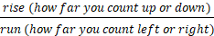. Plug this number in for m
    - Write the equation in the form y =mx + b
    - If there is a vertical line, the equation will be x = # where the graph crosses the x-axis
    - If there is a horizontal line, the equation will be y=# where the graph crosses the y axis

Function notation. Students must know that f(x) is read as "f of x" and means the same thing as y =. If the number given is in parenthesis, then students must plug in this number everywhere there is an x. If the number given is after the = sign, then students must plug in this number for f(x) and then solve the equation for x.
When looking at the graph, students must know that if the number is in parenthesis, then find this value on the x-axis. Then, follow this to the graph and find the corresponding y value. If the number is after the = sign, then find this value on the y-axis. Then, follow this to the graph and find the corresponding x value.
X values: domain, input, x values, independent variable (DIXI) ---usually written in numerical order (least to greatest)

Y-values: Range, output, y -values, dependent variable (ROYD) ---usually written in numerical order (least to greatest)

Relations or Function:
A relation is any set of ordered pairs (no other special rules)
A function is a relation where each input (x) has exactly one output (y) ; y's can repeat but x's cannot repeat
Example 1: ( 0, 7) ( 1, 5) ( 8, - 18) (3, 7)
This is a function since the x values do not repeat. The x-values are: 0, 1, 8, 3
Domain: {0, 1, 3, 8}
Range: {-18, 5, 7}

Example 2:
x | y
-2 | 3
0 | 5
0 | -16

This is not a function as the x value of 0 repeats. 0 has two outputs: 5 and – 16

Domain: {0, - 2}--------there is no need to write 0 twice
Range: {-16, 3, 5}

Graph must pass vertical line test in order to be a function; meaning if you draw a vertical line through the graph and it hits the vertical line 2 or more times, then it is not a function
The following website shows the vertical line test:
http://www.coolmath.com/algebra/15-functions/03-vertical-line-test-02

To evaluate functions: If the number is in the parenthesis, then plug in the number for x and follow order of operations (PEMDAS). If directions state to find x, then plug in the number given for f(x).

Example 1: f(x) = - 2x – 7
Evaluate: f(- 5)
f(- 5) = - 2(-5) – 7
f(- 5) = 10 – 7
f( - 5) = 3
This means when x = - 5, the y value is 3

Below are websites with videos explaining most of the concepts covered last semester. The notes I attached to the previous emails provide some examples that cover some of the concepts as well. Please use the websites below if students need a “refresher” of concepts learned first semester.

Solving Equations: https://www.youtube.com/watch?v=Z-ZkmpQBIFo
https://www.khanacademy.org/math/algebra-home/alg-basic-eq-ineq/alg-two-steps-equations-intro/v/steps-when-solving-equations
https://www.khanacademy.org/math/algebra/x2f8bb11595b61c86:solve-equations-inequalities/x2f8bb11595b61c86:linear-equations-variables-both-sides/v/equations-3

Solving Inequalities: https://www.google.com/search?q=Solving+Inequalities&rlz=1C1GCEA_enUS857US857&oq=Solving+Inequalities&aqs=chrome..69i57.7220j0j9&sourceid=chrome&ie=UTF-8#kpvalbx=_LDdxXoLQKuu7tgXRsZ2YCQ35

https://www.youtube.com/watch?v=VgDe_D8ojxw

Plotting Points: https://www.khanacademy.org/math/basic-geo/basic-geo-coord-plane/coordinate-plane-4-quad/v/plot-ordered-pairs
https://www.youtube.com/watch?v=s7NKLWXkEEE

Finding slope or rate of change: https://www.khanacademy.org/math/algebra/x2f8bb11595b61c86:linear-equations-graphs/x2f8bb11595b61c86:slope/v/slope-of-a-line

https://www.youtube.com/watch?v=R948Tsyq4vA

Graphing using x and y-intercepts: https://www.google.com/search?q=Graphing+linear+Equations&rlz=1C1GCEA_enUS857US857&oq=Graphing+linear+Equations&aqs=chrome..69i57.4547j0j4&sourceid=chrome&ie=UTF-8#kpvalbx=_TDhxXqKEKor0tAa947GQCA60

Graphing using y = mx + b: https://www.khanacademy.org/math/algebra/x2f8bb11595b61c86:forms-of-linear-equations/x2f8bb11595b61c86:standard-form/v/plotting-x-y-relationships

Systems of Equations: Remember this can be done on TI 36 XPRO calculator using 2nd tan buttons

https://www.khanacademy.org/math/algebra-home/alg-system-of-equations/alg-equivalent-systems-of-equations/v/solving-systems-of-equations-by-elimination

Simplifying Radicals: https://www.google.com/search?rlz=1C1GCEA_enUS857US857&ei=ADlxXtCDJMGFtQaGwYzwBg&q=Simplifying+Radicals&oq=Simplifying+Radicals&gs_l=psy-ab.3..0l10.4172.8904..9051...1.1..0.133.1707.18j2......0....1..gws-wiz.....2..0i71j0i362i308i361i357j0i67j0i273.Z2EFo8BSg5k&ved=0ahUKEwjQg6WgsqLoAhXBQs0KHYYgA24Q4dUDCAs&uact=5#kpvalbx=_lzlxXsbJLtC8tAaWkZrACw72 (ignore cube roots)

Adding/Subtracting Radicals: https://www.youtube.com/watch?v=MKwxPbITcXQ

Exponent Rules: https://www.youtube.com/watch?v=b4mSqcJND3I
https://www.khanacademy.org/math/algebra/x2f8bb11595b61c86:rational-exponents-radicals/x2f8bb11595b61c86:exponent-properties-review/v/multiplying-and-dividing-powers-with-integer-exponents

Adding/Subtracting Polynomials: https://www.google.com/search?rlz=1C1GCEA_enUS857US857&ei=kTxxXsqoPMqOtQWYvIhA&q=adding+and+subtracting+polynomials&oq=adding+and+subtracting+polyn&gs_l=psy-ab.1.0.0l10.1111.4336..7086...1.2..0.117.1042.13j1......0....1..gws-wiz.......0i71j0i67.Pg2GVypWeKM#kpvalbx=_mjxxXqLCCcHusQXk9pYY24

Multiply Polynomials: https://www.youtube.com/watch?v=wUYa2NAV5t4

