High School Foundations of Algebra (GSE)
Midterm Day 1 Review
1. The difference of 3 from a number.
A. -3n
B. n - 3
C. 3 - n
D. -3(n)

2. Which of the following shows the numbers in order from least to greatest:
A. 0.004, 0.6, 0.07, 0.32
B. 0.32, 0.004, 0.07, 0.6
C. 0.004, 0.07, 0.6, 0.32
D. 0.004, 0.07, 0.32, 0.6

3. Which property is demostrated by the following:
a(b + c) = ab + ac
A. Communtative Property
B. Associative Property
C. Identity Property
D. Distributive Property

4. Which of the following represents the associative property:
A. 1(x) = x
B. x + y + z = z + y + x
C. (x + y) + z = x + (y + z)
D. x(y + z) = xy + xz

5. Which equation illustrates the communtative property:
A. 1(p) = p
B. p + 0 = p
C. pq = qp
D. p(q + r) = pq + r

6. What are the term(s), coefficient, and constant described as the following as the following expression:
"the cost of 6 pizzas, c being the cost of each pizza, and a delivery charge of $5 is represented by 6c + 5 "
A. terms: 6c and 5 B. terms: 6c and 5 C. terms: 11c D. terms: 6c
coefficient: 6 coefficient: 5 coefficient: 11 coefficient: 6
constant: 5 constant: 6 constant: none constant: 5

7. Choose the expression that matches the following: "twice a number less than nine"
A. 7 - x
B. x - 7
C. 2x - 9
D. 9 - 2x

8. Mark borrowed $125 from his Dad to pay some bills. If he has already paid his dad back $30, how much does he still owe him? (let a = amount owed)
A. a + 125 = 30
B. a + 30 = 125
C. a - 30 = 125
D. a - 125 = 30

9. Which numbers represent solutions to the inequality below? CHECK ALL THAT APPLY
4(2c - 3) < 11c + 30
A. -17
B. -16
C. -15
D. -14
E. -13

10. Which is the solution 5 - 2(x - 3) = - 21?
A. - 16
B. - 15
C. 16
D. 15
11. Find the solution to:
1 - 5(b + 3) = b - (b - 1)
A. 0
B. 3
C. - 3
D. no solution

12. Solve:
2k - 5 + 6k = 2 + 5k - 1
A. 2
B. 1
C. 3
D. 5

13. Solve 10y + 7 - 4y = - 5 + 6y + 22
Identify how many solutions for this equation.
A. no solution
B. one solution
C. infinitely many solutions

14. -2(6v + 8) = -112
A. v = 8
B. v = 10
C. v = -16
D. v = -8

15. A company makes 5 blue cars for every 3 white cars it makes. If the company makes 15 white cars in one day. How many blue cars will it make?
A. 9
B. 13
C. 17
D. 25
16. 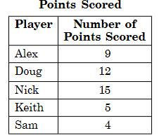
The table above shows the number of points that each player on a basketball team scored in his last game.
What percent of the total number of points did Alex score?
A. 9%
B. 20%
C. 25%
D. 45%

17.
Which ratio is correct to the number of apples to the number of peppers in the refrigator?
A. 1/4
B. 1/2
C. 3/4
D. 3/1

18. If , then x is equal to
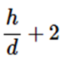
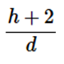
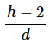
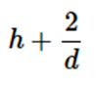
A. B. C. D.

19. Which choice is a graph of the solution set for

A. 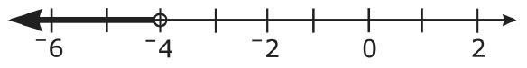
B. 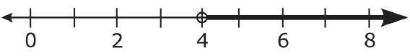
C. 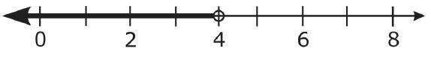
D. 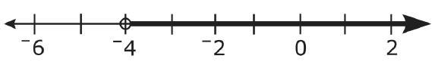

20. Orange Theory has more 5 more than 3 times as many bicycles as LA Fitness. Together they have 21 bicycles.
Solve the equation x+3x+5=21 to find the number of bicycles at Orange Theory.
A. 4 bicycles
B. 17 bicycles
C. 7 bicycles
D. 25 bicycles

