Percent Homework: Name: ______________________________
Solve each problem.
- What is 5% of 224? 2. 100 is what percent of 250?

- What is 63% of 300? 4. 10 is what percent of 625?

5. What is 18% of 650? 6. 0.4 is what percent of 5?

7. Find 75% of 312. 8. 1206 is what percent of 8040?

9. 13 is 50% of what number? 10. 13 is 50% of what number?

11. 52.3 is what percent of 1046? 12. 3570 is 42% of what number?
13. Katie’s food bill at a restaurant was $20. She decided to leave a 15% tip. How much tip did she
leave?

14. Seven wins out of ten games is what percent?

15. Brandon sold 13 computers this week. This was 4% of the computers in stock. How many computers
were in stock?

16. The members of the school band sold $1800 worth of fruit. This was 60% of their fundraising goal.
How much was their goal?

17. If a person who weighs 70 kilograms has a brain that weighs 1.4 kilograms, what percent of the
person’s body weight is brain?

Unit Rate Homework Name: ____________________________
Find each unit rate. Round your answer to the nearest hundredth:

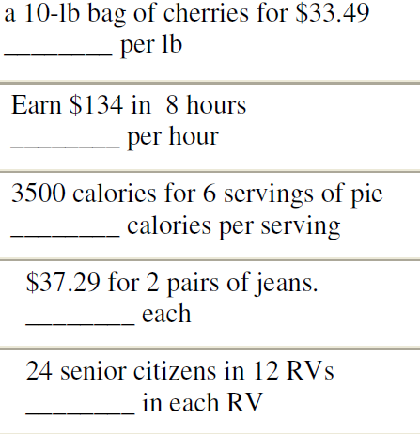

Which is the better buy:
