Notes for Percents:

Setup: $\frac{Percent}{100}$ = $\frac{is}{of}$ Remember: If x is over a 100 or the problem states what percent,
then there must be a percent sign attached to your answer.

Ex 1: 21 is what percent of 35? Ex 2: What is 122% of 175? Ex 3: 9 is 45% of what number?

Ex 4: A baseball pitcher won 80% of the games he pitched. If he pitched 35 ballgames, how many games
did he win?

Ex 5: There are 28 students in a class. Sixteen of those students are men. What percent of the class are
women? (Round to the nearest tenth)

Ex 6: A student earned a grade of 80% on a math test that had 20 problems. How many problems on
this test did the student answer correctly? (round to the nearest whole number)

Ex 7: A student answered 86 problems on a test correctly and received a grade 98%. How many problems were on the test, if all the problems were worth the same number of points? (Round to the nearest whole number)

Notes for Unit Rates:

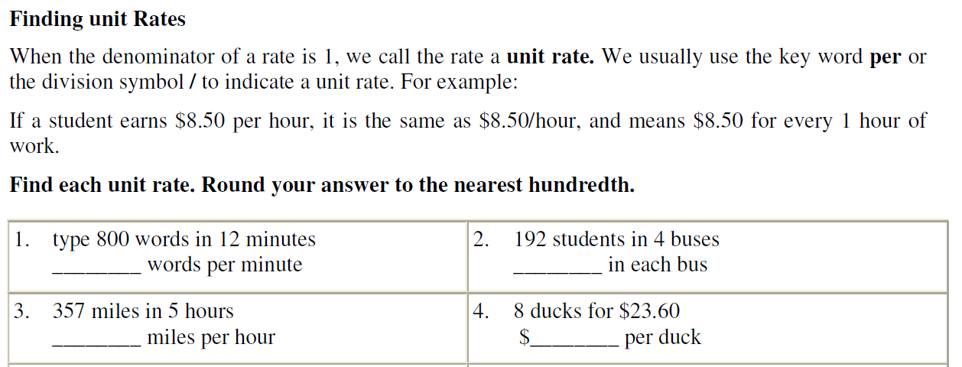

Which is the better buy:
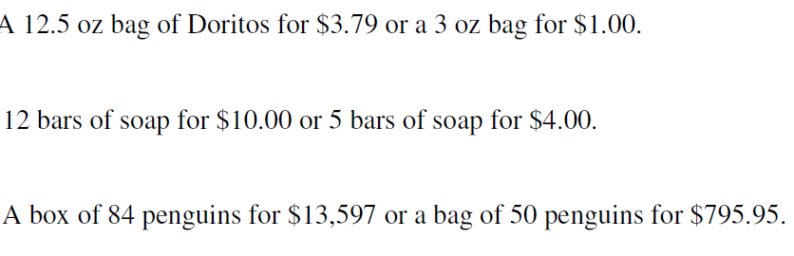
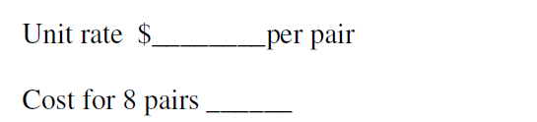

11 game season
